**MALATHIKA V**

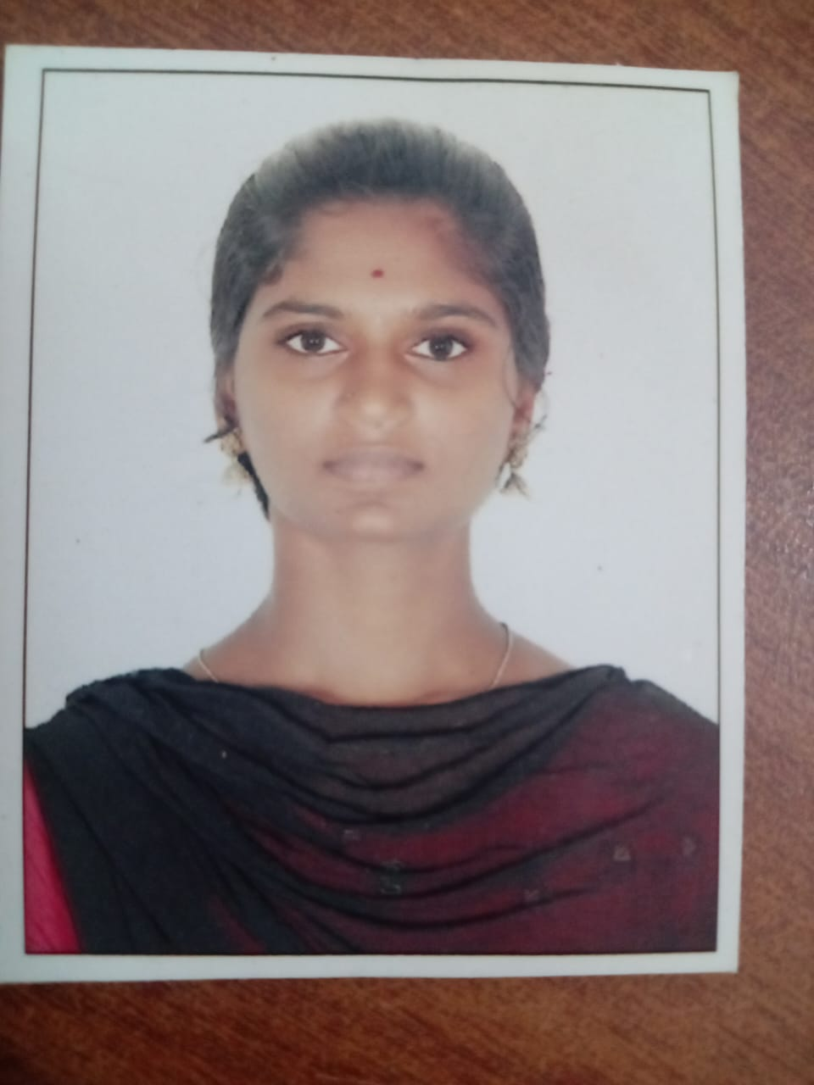

D/O.Valavarasu M

161, Ambalakarar street, cholapuram,

orathanadu Tk, Thanjavur Dt.

PINCODE:614902

Phone:8870707783

Email:kk9644719@gmail.com

**Objectives:**

* I seek challenging opportunities where I can fully use my skills for the success of the organization

1. **Skill Sets:**
   * Through knowledge in accountancy.
   * Good knowledge about marketing management.
   * Good communication skills.
   * English speaking.
   * Reasoning ability.
2. **Computer Skills:**
   * Programming language : JAVA, C, C++, Python
   * MS WORD.
   * MS EXCEL.
   * POWER POINT.
3. **Education Qualification:**

|  |  |  |  |
| --- | --- | --- | --- |
| Name of Exam | Name of Board | Passing year | Percentage (%) |
| 10th | SSLC | 2019-2020 | ALL PASS |
| 12th | HSC | 2021-2022 | 78% |
| BCA(Bachelor of Computer Applications) | Bharathidhasan  University | 2023-2026 | 87% |

**Personal Details:**

Date of birth : 19.04.2005

Nationality : India

Marital status : Single

Religion : Hindu

Gender : Female

Place : Tamil Nadu